Oscillators
This Chapter is the first of three chapters on scheduled source nodes in the Web Audio API. It focuses on OscillatorNodes, their methods and use. Some essential Fourier theory is provided and the concept of aliasing is explained in order to understand how oscillators are constructed. Each parameter of the Oscillator Node is explained in detail. Source code examples are given to demonstrate use of the built-in oscillator types, varying the oscillator's frequency, and detuning the pitch. Several examples are also provided for creating custom oscillators using the PeriodicWave, including a square wave that we will see constructed in other ways in other chapters.

A bit of theory
Oscillators are just periodic waveforms. They are pervasive in sound design, and the building blocks of many synthesis techniques. In fact, Fourier theory is built around the fact that signals can be represented as the sum of oscillators, so an understanding of oscillators and oscillation is at the core of all signal processing.
The basic oscillators are trivial, just signals like sine waves or square waves. But a deep theoretical understanding involves entire textbooks on the subject. We won’t go that far here, but we will introduce some theory when necessary.
Consider a continuous periodic function, sampled at a frequency f_{s}. This sampled signal cannot reproduce frequencies above f_{s}/2. As an example of this, consider Figure 2.1. A sinusoid of frequency 0.7f_{s} is sampled at frequency f_{s}. The samples that result could equally well represent a sinusoid of frequency 0.3f_{s}. In fact, for sampling frequency f_{s}, any periodic signal with frequency f_{c}, where 0 ≤ f_{c} < f_{s}/2, will be indistinguishable from the same signal with frequency Nf_{s} + f_{c} or Nf_{s} – f_{c}, for any N. This property is known as aliasing, since these signals are aliases of each other.
One of the main reasons that aliasing is problematic is because it means that frequencies above f_{s}/2 may be interpreted as lower frequencies that were never present in the original signal. In many cases this will cause audibly objectionable artifacts. This can be avoided by always sampling a signal at a frequency at least twice that of the highest frequency present in the signal, or conversely, removing all frequencies higher than half the sampling rate before sampling. This is known as the Shannon-Nyquist sampling theorem after the two main people who discovered this property, and it is a core principle of digital signal processing. f_{s}/2 is known as the Nyquist frequency.
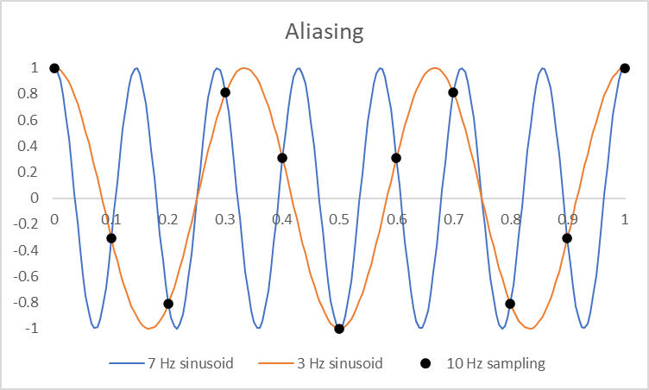
Figure 2.1. Two sampled sinusoids, one with frequency 3 Hz and the other with frequency 7 Hz . They appear identical when sampled at a frequency 10 Hz, since 5-3 = 7-5.
Now note that any periodic function x(t) with frequency f₀ can be represented by a Fourier series,
$$x\left(t\right)=\frac{a_{0}}{2}+\sum_{n=1}^{∞}{\left[a_{n}\cos{(2π{nf}_{0}t)}+b_{n}\sin{(2πnf_{0}t)}\right]}$$ | (2.1)
for some set of real valued coefficients, a and b. There are many different ways to represent the Fourier series. For instance it can also be given in the form of a complex exponential, in which case the coefficients are complex and a coefficients represent real terms and b coefficients represent imaginary terms.
The Fourier series provides a convenient way to approximate sampled signals such that aliasing does not occur. If we sample a signal at a sampling frequency fs, we take that signal’s Fourier series and only keep the terms in the series up to nf₀ < f_{s}/2.

OscillatorNode
The Web Audio API provides a simple means to generate well-known periodic waveforms, or design your own one, with the OscillatorNode. It is an AudioScheduledSourceNode that starts emitting sound at the time specified by the start() method.

Parameters
- type: The shape of the periodic waveform. It may be set directly to any of the waveforms, 'sine' (the default), 'square', 'sawtooth', or 'triangle'. It can also be set to 'custom' using the setPeriodicWave() method. In which case, any other valid value for type is ignored. See below for an explanation of the oscillator types.
- frequency: The frequency (in Hertz) of the periodic waveform. Its default value is 440 and it can range from -Nyquist to +Nyquist, where Nyquist .
- detune: A detuning value (in cents) which will offset the frequency by the given amount. Its default value is 0.
Together, the frequency and detune form a compound parameter, which is the actual frequency of the oscillator, computedOscFrequency = frequency⋅2^{detune / 1200}

The oscillator types
The built-in oscillator types include the sine, triangle, sawtooth, and square waves. Their idealized waveforms are depicted in Figure 2.2, and defined as folllows. They are all odd functions, meaning $x\left(-t\right)=-x\left(t\right)$ with a positive slope at time 0.
- 'sine' : x(t)=sin($2πf_{0}t$)
- 'square': $x\left(t\right)=sgn\left(sin\left(2πf_{0}t\right)\right)$
- 'sawtooth':$x\left(t\right)=2·frac\left(f_{0}t\right)-1$
- 'triangle':$x\left(t\right)=1-4\left|frac\left(f_{0}t+1/4\right)-1/2\right|$
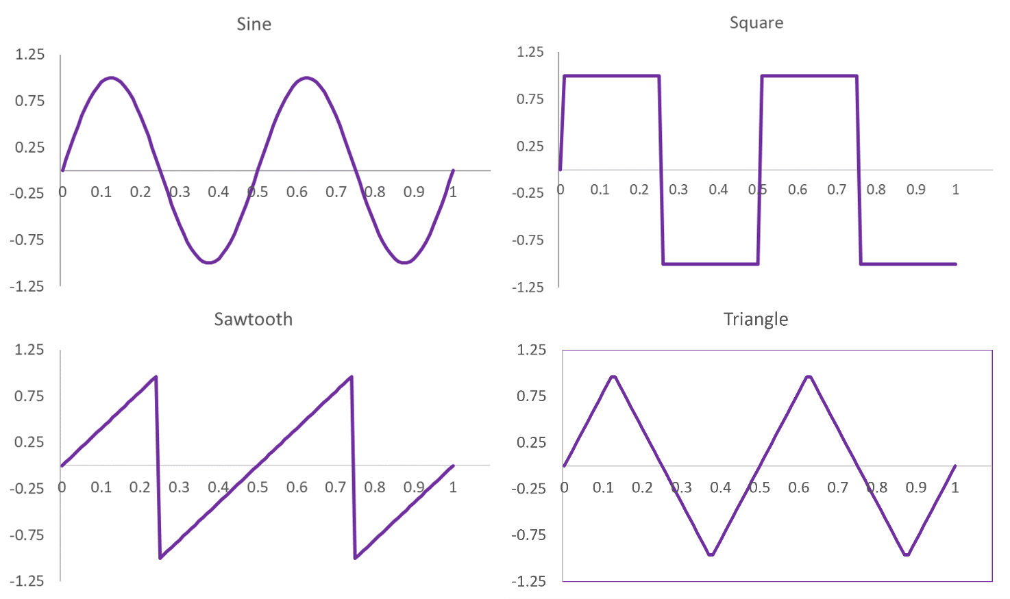
Figure 2.2. The ideal forms of the types supported by an OscillatorNode. In each case, 2 periods are shown of an oscillator with 2 Hz frequency.
Where f₀ is the computed frequency of the oscillator (the frequency parameter if detune is 0), and frac() refers to the fractional part of a number. However, each of these idealized forms is actually approximated using the Fourier series of Equation (2.1), where the a coefficients are all set to 0 and N is the largest integer such that Nf₀ is less than f_{s}/2,
$$x\left(t\right)=\sum_{n=1}^{N}{b\left[n\right]\sin{2}πnf_{0}t.}$$ | (2.2)
In other words, only the terms in the Fourier series less than Nyquist are kept, so that no aliasing occurs. The Fourier series coefficients are as follows;
- 'sine':$b\left[n\right]=\left\{\begin{matrix}1 & n=1 \\ 0 & otherwise\end{matrix}\right.$
- 'square':$b\left[n\right]=\frac{2}{nπ}{(1-\left(-1\right)}^{n})$
- 'sawtooth': $b\left[n\right]={\left(-1\right)}^{n+1}\frac{2}{nπ}$
- 'triangle': $b\left[n\right]=\frac{8\sin{\frac{nπ}{2}}}{{\left(πn\right)}^{2}}$
This truncated Fourier series is exact for the sine function, but the actual waveforms for the square, sawtooth and triangle types are approximations of the idealized waveforms; very close approximations for low frequencies f₀, and worse approximations as f₀ approaches f_{s}/2.
So, for example, a sawtooth wave of frequency f₀=5000 with a sample rate of 44,100 will have only the first four terms in the series, and gets approximated as;
$$x(t)=\frac{2sin\left(2πf_{0}t\right)}{π}-\frac{2sin\left(4πf_{0}t\right)}{2π}+\frac{2sin\left(6πf_{0}t\right)}{3π}-\frac{2sin\left(8πf_{0}t\right)}{4π}$$ | (2.3)

Example – basic use of the OscillatorNode
<button onclick='context.resume()'>Start</button>
<p>Frequency</p>
<input type='range' max=1000 value=440 id='Frequency'>
<p>Gain</p>
<input type='range' max=1 step='any' value=0.2 id='Volume'>
<p>Type</p>
<select id='Type'>
<option value='sine'>Sine</option>
<option value='square'>Square</option>
<option value='sawtooth'>Sawtooth</option>
<option value='triangle'>Triangle</option>
</select>
<script src='Oscillator.js'></script>

//Define variables
var context = new AudioContext()
var Tone = new OscillatorNode(context)
var Amplitude = new GainNode(context,{gain: 0.2 })

//Set up audio graph
Tone.connect(Amplitude)
Amplitude.connect(context.destination)
Tone.start()

//User interface callbacks
Frequency.oninput = function() { Tone.frequency.value = this.value }
Volume.oninput = function() { Amplitude.gain.value = this.value }
Type.onchange = function() { Tone.type = this.value }

Code example 2.1. Oscillator.html and Oscillator.js
Code example 2.1 shows how a simple, configurable oscillator can be rendered. It builds on the examples from Chapter 1, but now the user has control of the frequency and type. We change the type of oscillator with a select control, which gives a dropdown menu. The oscillator is connected to a gain node, so that the level can be changed as well. When the user changes the values of these controls, it will update the respective parameter of the desired audio node.

The PeriodicWave
The periodicWave is the Web Audio API’s way of using wavetables to efficiently create arbitrary wave shapes. This is a form of additive synthesis, where signals are constructed by summing many simpler signals. For the implementation here, we synthesize a periodic signal with frequency f₀ by summing many sinusoids at multiples of the frequency f₀.
First, a periodicWave must be created using the method createPeriodicWave(). This takes two arrays a[] and b[], to specify the Fourier coefficients of a periodic waveform, as given by Equation (2.1). These float arrays must be the same length. The first element of the a[] array is ignored, so there is no constant or DC offset to the waveform. The first element of the b[] array is also ignored, since it is not used in the Fourier series ( sin(0) = 0 ).
If only one of a or b is specified, the other is treated as if it were an array of all zeroes of the same length. If neither is given, a PeriodicWave is created with the element at index 1 of b[] set to 1. This is equivalent to using the built-in type 'sine'. If both are given, the sequences must have the same length.
A third parameter disableNormalization, controls whether the periodic wave is normalized or not. By default it is set to false, meaning that the waveform is normalized such that the resulting waveform will have a maximum value of 1. The normalization is done by finding the maximum value of the (time domain) periodic wave, and then dividing the waveform by that maximum.
Now that a periodicWave has been created, we can use the OscillatorNode’s setPeriodicWave(periodicWave) method to set it as the custom type for an oscillator. When this method is called, it is treated as if 'custom' were specified for the type and any other value is ignored.
So generating an oscillator node based on a custom waveform is really a four step process;
- Create an OscillatorNode.
- Define the a[] and b[], arrays to specify the Fourier series coefficients.
- Create a periodicWave using the a[] and b[] arrays.
- Call the OscillatorNode’s setPeriodicWave method using the periodicWave you just created.
Finally, note that the periodic wave can be used by several oscillators. It is a method of the audio context, not of an oscillator node. But also since it is created using an audio context’s method, it cannot be shared with other audio contexts.

Square Wave Example
The standard oscillator types (sine, square, sawtooth and triangle) could all have been generated using a PeriodicWave, with the appropriate Fourier series and with disableNormalization set to false.
Lets do this for the square wave, shown in Code example 2.2. From (2.2) and the definition of the Fourier coefficients for the square wave, the Fourier series can be written as,
$$x\left(t\right)=\sum_{n=1}^{N}{b\left[n\right]\sin{2}πnf_{0}t,} \\ b\left[n\right]=\left\{\begin{matrix}4/(nπ) & n is odd \\ 0 & n is even\end{matrix}\right.$$ | (2.4)
Since the a terms are all 0, we simply define the a array to be empty and set the b array terms based on this formula. The array lengths are set high so that we can keep many terms in the Fourier series. Only terms below Nyquist are used for creating the periodic wave, so aliasing does not occur even though terms higher than Nyquist may have been defined.
As with the built-in oscillator types, the oscillator's frequency can be changed directly. When the frequency is modified, the coefficients in the Fourier series don't change, they are just acting on multiples of a different fundamental frequency. So in every sense, once the periodic wave is set, one can use this oscillator just like any other.

<button onclick='context.resume()'>Start</button>
<p>Frequency</p>
<input type='range' min=1 max=1000 value=10 id='Frequency'>
<script>
let context= new AudioContext()
let source= new OscillatorNode(context,{frequency:10})
var maxCoef= context.sampleRate/(2*source.frequency.value)
var a = new Float32Array(context.sampleRate/2)
var b = new Float32Array(context.sampleRate/2)
for (i=1;i<maxCoef;i+=2) b[i]= 4/(i*Math.PI)
source.setPeriodicWave(context.createPeriodicWave(a,b))
source.start()
Frequency.oninput = () => { source.frequency.value = Frequency.value }
source.connect(context.destination)
</script>

Code example 2.2. CustomSquareWave.html, a square wave generator using the PeriodicWave.

Pulse Wave Example
The square wave is actually a special case of a pulse wave. This waveform has an additional parameter, the duty cycle, which is the percentage of its period spent at its maximum value. So the square wave would have duty cycle of 50%.
Let’s consider a pulse wave with a few more differences from the square wave. It has period T, and will spend D of its time at 1 and 1-D of its time at 0, where D is the duty cycle, expressed as a ratio. We’ll make it an even function so that it is at its maximum from time -DT/2 to +DT/2. We can write one period as;
$$x\left(t\right)=\left\{\begin{aligned}1, \left|t\right|≤\frac{DT}{2} \\ 0, \left|t\right|>\frac{DT}{2}\end{aligned}\right., -\frac{T}{2}<t≤\frac{T}{2}$$ | (2.5)
Since it is an even function, the Fourier series only has cosine terms (all b coefficients are zero). The DC offset is just a₀=D/T. The remaining terms are found from;
$$a_{n}=\frac{2}{T}\int_{-T/2}^{T/2}{x\left(t\right)\cos\left(n2πf_{0}t\right)dt}=\frac{2sin(nπD)}{nπ}$$ | (2.6)
We can now generate a periodic wave with this form, and set that as the wave for an oscillator node. This is shown in Code example 2.3, which uses the PeriodicWave to create a pulse wave.
Recall that the Web Audio API automatically sets the a[0] and b[0] terms to zero, regardless of how the arrays are defined. So any offset to the waveform should not be applied by setting a[0]. Instead, it can be dealt with by using a constant source node as an additional input to wherever the OscillatorNode goes.
Also, note that the periodic wave is recalculated whenever the duty cycle is changed, since this changes the coefficient values. We didn’t recalculate the periodic wave when the frequency parameter changes since the coefficient values are independent of the periodic wave’s frequency, though changing the frequency can affect the number of terms below Nyquist.
The periodic wave generated by this code is shown in Figure 2.3. Here, one can see the effect of a finite number of terms in the Fourier series, as well as the effect of the duty cycle.
<button onclick='context.resume()'>Start</button>
<p>Frequency</p>
<input type='range' min=1 max=1000 value=10 id='Frequency'>
<p>Duty Cycle</p>
<input type='range' max=1 step='any' value=0.5 id='DutyCycle'>
<script>
let context= new AudioContext()
let source= new OscillatorNode(context,{frequency:10})
var maxCoef= context.sampleRate/(2*source.frequency.value)
var a = new Float32Array(context.sampleRate/2)
var b = new Float32Array(context.sampleRate/2)
a[0]=0,b[0]=0
for (i=1;i<maxCoef;i++) a[i]= 2*Math.sin(i*Math.PI*DutyCycle.value)/(i*Math.PI)
source.setPeriodicWave(context.createPeriodicWave(a,b))
source.connect(context.destination)
source.start()
Frequency.oninput = function() { source.frequency.value = this.value }
DutyCycle.oninput = function() {
//Recalculate the coefficients, up to Nyquist, for this new Duty Cycle
maxCoef= context.sampleRate/(2*source.frequency.value)
for (i=1;i<maxCoef;i++) a[i]= 2*Math.sin(i*Math.PI*DutyCycle.value)/(i*Math.PI)
//now reset the periodic wave
source.setPeriodicWave(context.createPeriodicWave(real,imag))
}
</script>
Code example 2.3. PulseWave.html, a pulse wave generator.
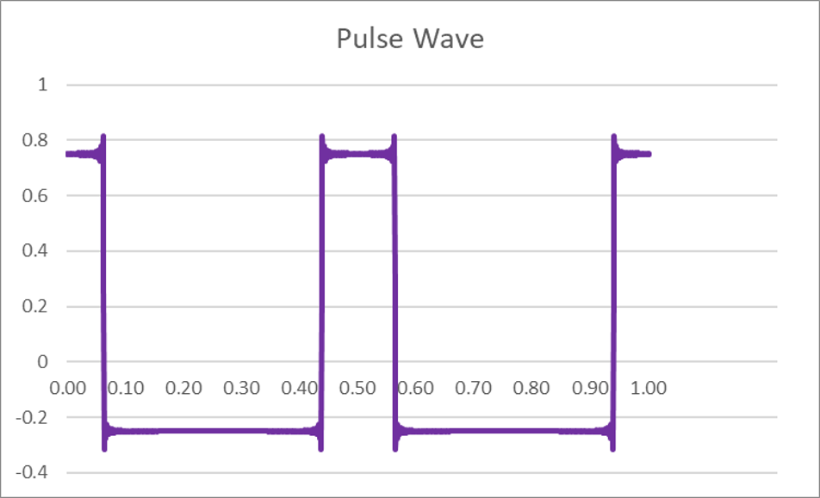
Figure 2.3. PeriodicWave.html. A pulse wave with frequency 2 Hz and duty cycle 25%, generated from CreatePeriodicWave. Note that since the DC offset term is set to zero, the average value is 0.

The Detune parameter
In addition to frequency and type, the OscillatorNode also has a detune parameter. To understand this parameter, its worth first discussing some basic aspects of musical pitch and its notation.
We can move a musical note one octave higher by doubling the frequency of the note. And similarly, we can lower it by an octave if we halve the frequency. Thus, pitch (like volume) is perceived exponentially by our ears: at every octave, the frequency doubles.
In twelve-tone equal temperament musical tuning, which is the system used for most Western and classical music, each octave is split up into 12 semitones. These semitones have identical frequency ratios. So if f₀ is some frequency, f₁ is one octave higher, and k is the multiplier to move the pitch up one semitone, then
f₁ = f₀k¹²= 2f₀
Thus,
k = 2^{1/12} = 1.0595 . . .
Each semitone is further divided into one hundred cents, so that an octave is 1200 cents. Hence an increase in pitch of one cent would multiply the initial frequency by 2^{1/1200}.
To work with this musical tuning system, the Web Audio API includes an audio parameter called detune, in the OscillatorNode, BiquadFilterNode and AudioBufferSourceNode. detune shifts the actual frequency associated with the node by some amount in cents.
For the OscillatorNode, if f₀ is the value of the audio parameter frequency, then the frequency of the oscillator produced by the node is
f_{computed} = 2^{detune(t) / 1200} f₀.
So by specifying a detune of 1200, you move up an octave. Specifying a detune of −1200 moves you down an octave. The default value of detune is 0, meaning that the computed frequency is the same as the frequency parameter value.
Since the only effect of the detune parameter is to shift the frequency, this parameter is unnecessary. That is, if one wants to detune the frequency of some oscillator Tone by x cents, one could also do this by modifying the frequency directly,
Tone.frequency = Math.pow(2,x/1200)*Tone.frequency;
However, having this as an audio parameter of the node is useful and intuitive for musical composition, or indeed for anyone who wants to work with the musical scale while using the web audio API.

Example – detuning an oscillator
Code example 2.4 shows the use of the detune parameter. We have an oscillator which can be detuned in units of 100 cents. The tunings have the names in the common twelve-tone equal temperament tuning system. The initial frequency is set to 261.63 Hz, which is Middle C on a piano keyboard. So, for example, moving up two semitones (one tone) is a major second and involves changing the pitch 200 cents, to Middle D at about 293.67 Hz.
<button id='startButton' onclick='context.resume()'>Start</button>
<hr>
<select id='interval'>
<option value=0 selected>Unison</option>
<option value=100>Minor second</option>
<option value=200>Major second</option>
<option value=300>Minor third</option>
<option value=400>Major third</option>
<option value=500>Perfect fourth</option>
<option value=600>Tritone</option>
<option value=700>Perfect fifth</option>
<option value=800>Minor sixth</option>
<option value=900>Major sixth</option>
<option value=1000>Minor seventh</option>
<option value=1100>Major seventh</option>
<option value=1200>Octave</option>
</select>
<br><br>
Frequency (Hz)<br>
<input id='freqSlider' type='range' min=20 max=2000 step='any' value=261.63>
<input id='freqNumber' type='number' min=20 max=2000 step='any' value=261.63><br><br>
Detune (cents)<br>
<input id='detuneSlider' type='range' min=-1200 max=1200 step=1 value=0>
<input id='detuneNumber' type='number' min=-1200 max=1200 step=1 value=0><br>
<script src='detune.js'></script>

var context = new AudioContext()
var osc = new OscillatorNode(context,{frequency:261.63})
osc.connect(context.destination)
osc.start(0)
freqNumber.oninput = function () {
osc.frequency.value = freqNumber.value
freqSlider.value = this.value
}
freqSlider.oninput = function () {
osc.frequency.value = freqNumber.value
freqNumber.value = this.value
}
detuneNumber.oninput = function () {
osc.detune.value = detuneNumber.value
detuneSlider.value = this.value
}
detuneSlider.oninput = function () {
osc.detune.value = detuneNumber.value
detuneNumber.value = this.value
}
interval.oninput = function () {
osc.detune.value = this.value
detuneSlider.value = this.value
detuneNumber.value = this.value
}

Code example 2.4. Detune.html and Detune.js
With this code example, one can change the pitch by changing the frequency, selecting a semitone interval, or changing the detune amount. Here, we have both range and number controls for frequency and detune parameters, where changing the range control will update the number and vice versa. So the user can make fine adjustments by editing the number or quick adjustments by moving the slider. If one of the musical intervals is selected with the 'interval' select element, then the oscillator is detuned by the exact amount associated with that interval.
Among other things, by adjusting the controls, you can hear that detuning by 1200 cents is equivalent to doubling the frequency.

The Web Audio API documentation sometimes refer to these as the real[] and imag[] arrays, in reference to the complex Fourier series.

